**Name – Mukul Jindal**

**Group – 3CS10**

**Roll No – 102116063**

1. Ipconfig (Windows)

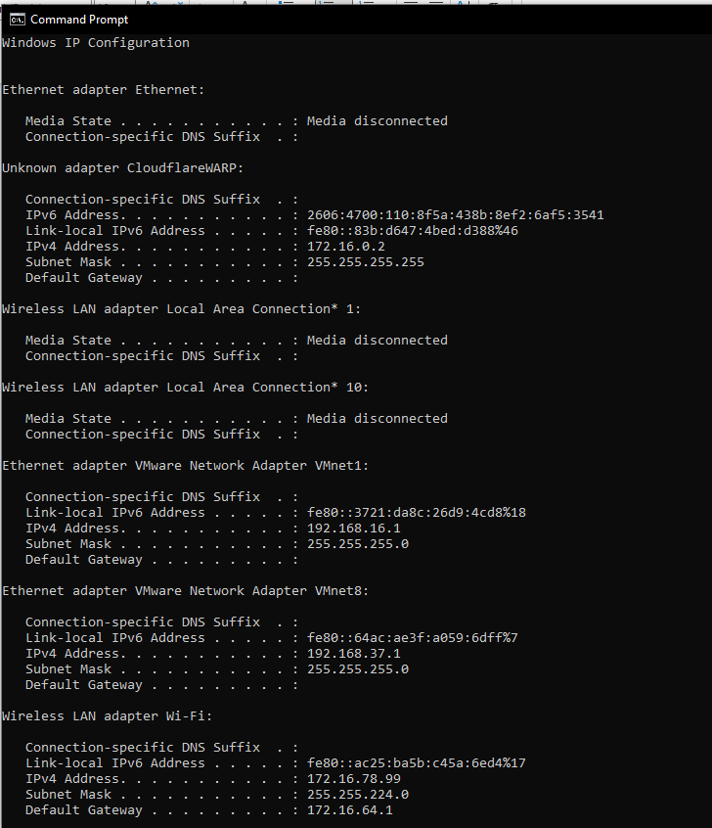

1. ifconfig (Linux)

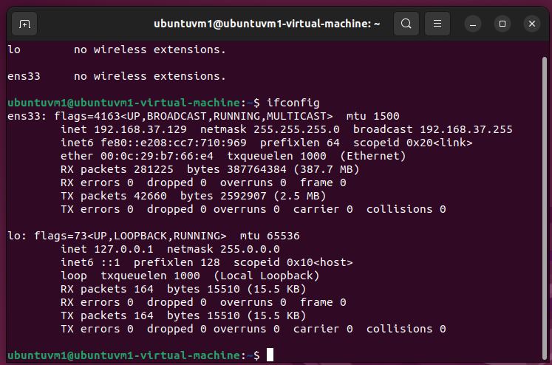

1. ifconfig [hardware_name] down (Linux)

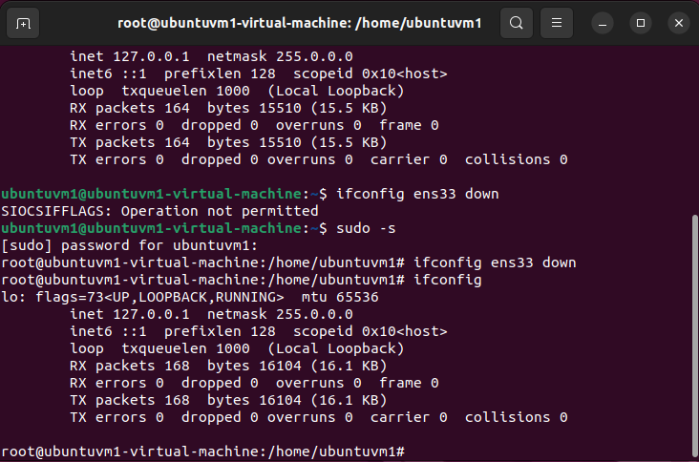

1. ifconfig [hardware_name] up (Linux)

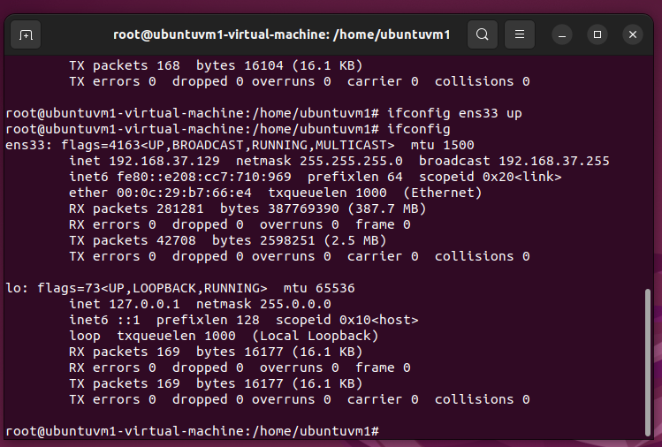

1. ifconfig [hardware_name] mtu [new_size] up

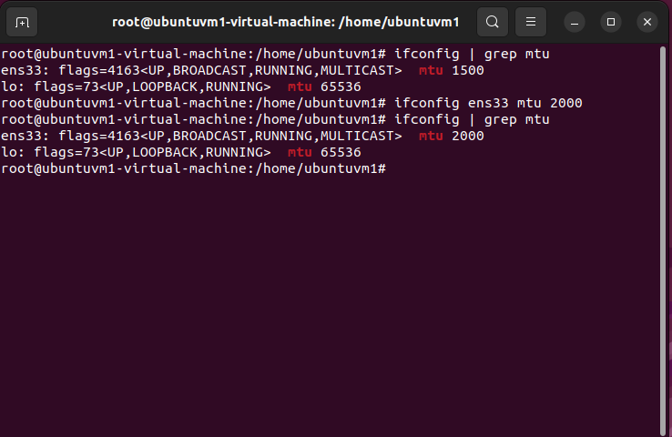

1. ifconfig (Windows)

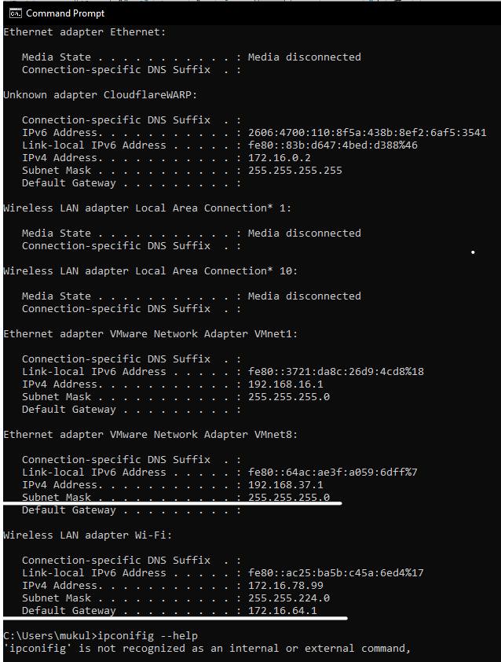

1. ifconifg(Linux)

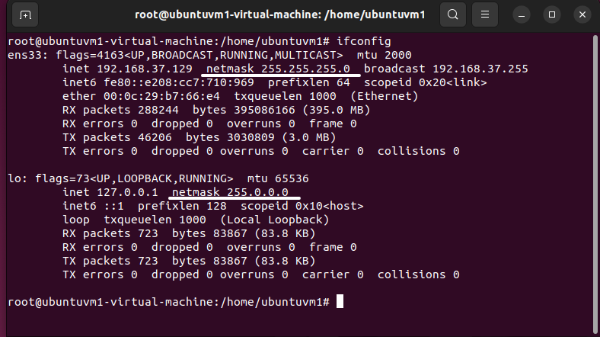

1. Calculating number of host Id’s

In Windows we get subnet mask as 255.255.224.0 i.e., we get number of reserved bits = 19 bits, so remaining bits are 32 – 19 i.e., 13 bits. So, number of host id can be 213, out of which first Id is considered as network address and last address as broadcast address

1. Calculating network address

Step1: Write the given IP address in binary format.

Step 2: Write the subnet mask in binary form.

Step3: Perform the logical  ANDing operation between the corresponding octets of the IP address and the subnet mask.

Step 4: Convert the result back to the decimal format and this will be the network address.

Ip address: 172 16 78 99

Binary - 10101100 00010000 01001110 01100011

Subnet(Binary)- 11111111 11111111 11100000 00000000

Logical AND 10101100 00010000 01000000 00000000

Decimal 172 16 64 0

Therefore, Network address is 172.16.64.0

1. Calculating broadcast address

Step1: Write the given IP address in binary format.

Step 2: Write the inverse of the subnet mask in binary form.

Step: Perform the logical  ORing operation between the corresponding octets of the IP address and the inverse of the subnet mask.

Step 4: Convert the result back to the decimal format and this will be the network address.

Ip address: 172 16 78 99

Binary - 10101100 00010000 01001110 01100011

Subnet(Binary)- 00000000 00000000 00011111 11111111

Logical OR 10101100 00010000 01011111 11111111

Decimal 172 16 95 255

Therefore, Broadcast address is 172.16.95.255

1. Ping
2. ping [IP_Address/Domain_name]

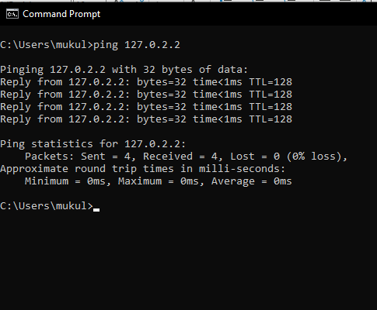

1. ping [IP_Address/Domain_name] /n[no_of_packets]

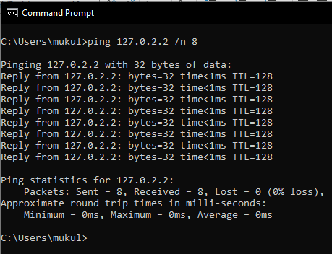

1. ping [IP_Address/Domain_name] /n[no_of_packets] /l [size_of_packet]

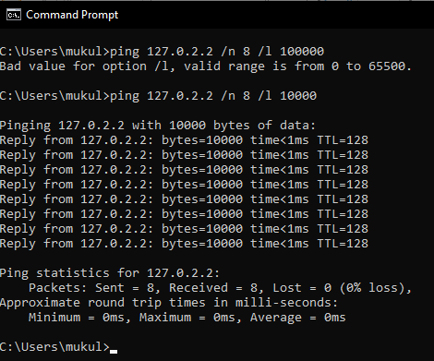

1. Device Mac Address

Windows

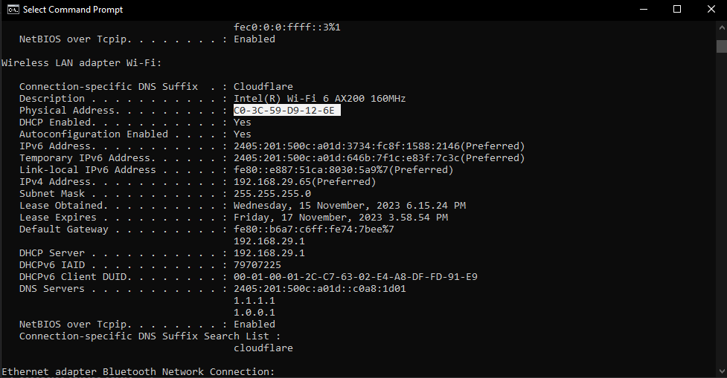

Linux

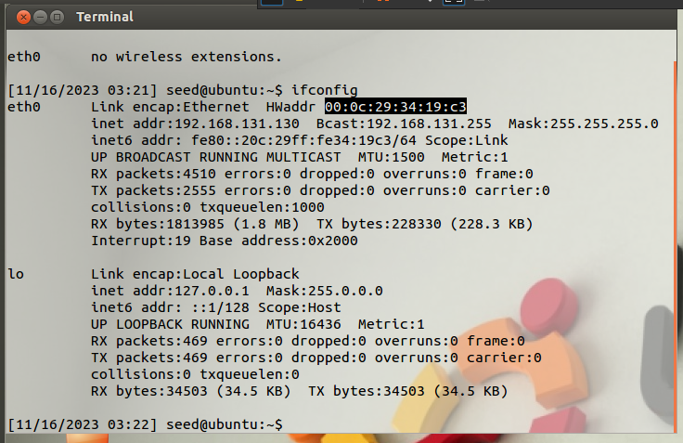

1. . Public and Private IP

Private IP:

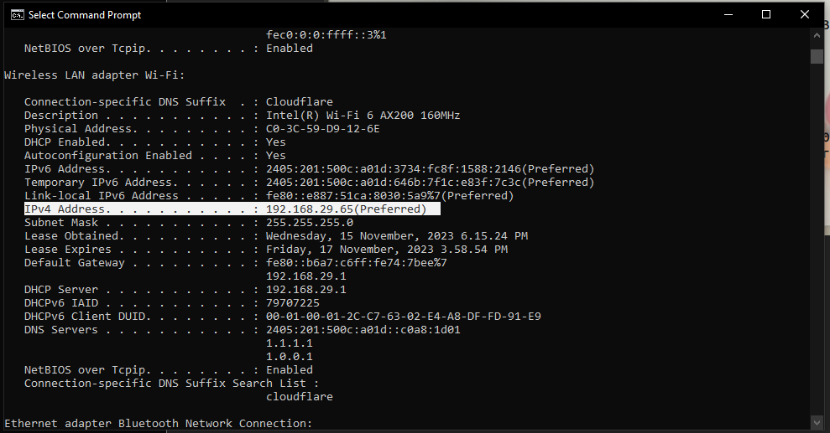

Public IP:

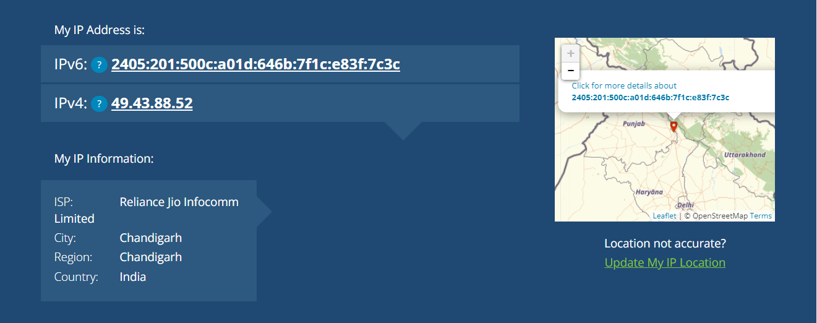

1. Look for the default gateway and firewall

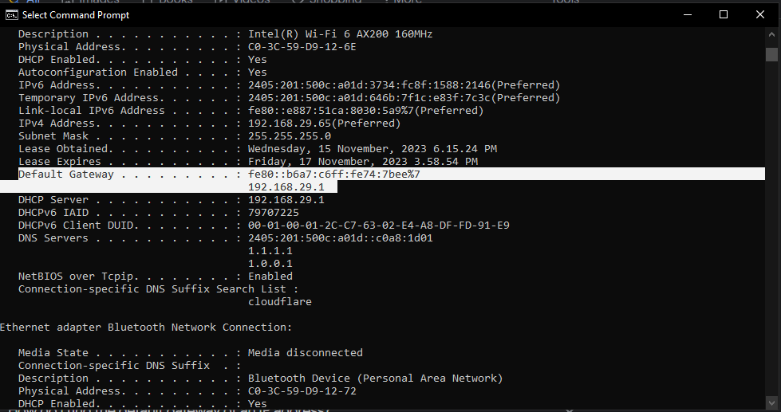

12 DHCP Servers

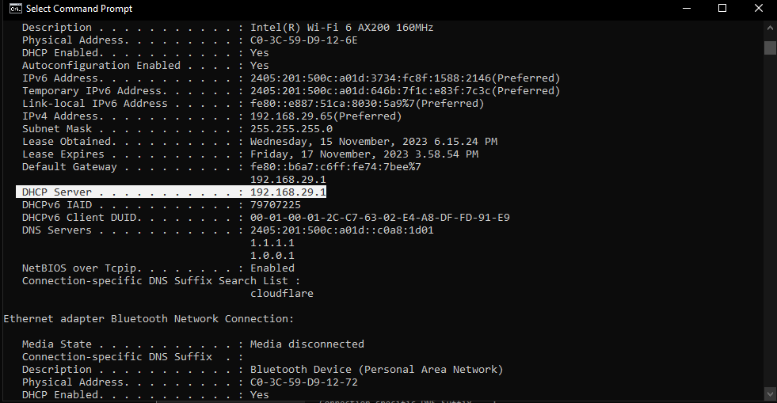

13 Count number of hosts travelled by packet to reach the destination organization. What is the IP address of second last host.

